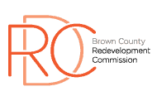

Brown County Redevelopment Commission

**COUNTY ANNEX BUILDING – SALMON ROOM**

Agenda – July 15, 2025

Call to Order

Roll Call

Review/Approval of Minutes – June 17, 2025

Old Business

* RDC website – Chris
* “PLAYBOOK” – Chris & Jeremiah
* Site visit status – Amy & David

New Business

* RED grant from OCRA
  + <https://www.in.gov/ocra/red/>
* Quality of Life Committee – 3% Innkeepers Tax – Amy & Sue
* County Comprehensive Plan 2025 Draft
  + - Review/Discussion
    - Identify top priorities

Other Business

Public Comment

Adjournment

Next Meeting: August 19, 2025, 6:00 PM